VLSI Design Internship - Task 2 Report
Introduction
This project focuses on the implementation of basic combinational circuits using Verilog HDL. The task was performed using Xilinx ISE Design Suite for coding, simulation, and verification. The objective of this task is to understand RTL (Register Transfer Level) design concepts, basic Verilog syntax, logic gate implementation, and behavioral simulation techniques.

Objectives of the Task
• Learn the fundamentals of Verilog HDL
• Understand module structure and syntax
• Design combinational logic circuits
• Implement logic gates using Verilog
• Create Half Adder and Full Adder circuits
• Write testbench modules for verification
• Perform behavioral simulation and waveform analysis
• Gain practical exposure to VLSI design flow

Implemented Circuits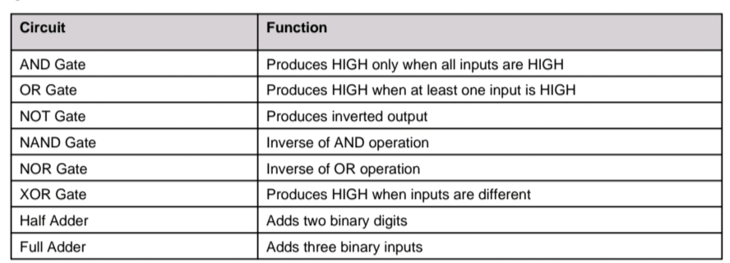
Sample Verilog Code - AND Gate

module and_gate(
input a,
input b,
output y
);
assign y = a & b;
endmodule
Simulation and Testbench
For each circuit, a separate Verilog testbench was created to verify functionality. Different input combinations were applied using simulation delays. Behavioral simulation was performed using ISim Simulator available in Xilinx ISE Design Suite. Waveforms were analyzed to confirm correct logical outputs

Tools and Technologies Used
• Verilog HDL
• Xilinx ISE Design Suite
• ISim Simulator
• GitHub for project repository management

Learning Outcomes
This task improved understanding of digital electronics and RTL design concepts. It provided hands-on experience in writing Verilog code, debugging syntax errors, creating testbenches, and analyzing simulation waveforms. The project also helped in understanding the practical workflow used in VLSI front-end design.

Conclusion
The successful implementation of logic gates, Half Adder, and Full Adder circuits demonstrates the practical application of Verilog HDL in digital system design. The project enhanced knowledge of combinational circuit design, simulation techniques, and GitHub documentation practices required for VLSI engineering projects.

